AWS EBS vs Object store(S3) 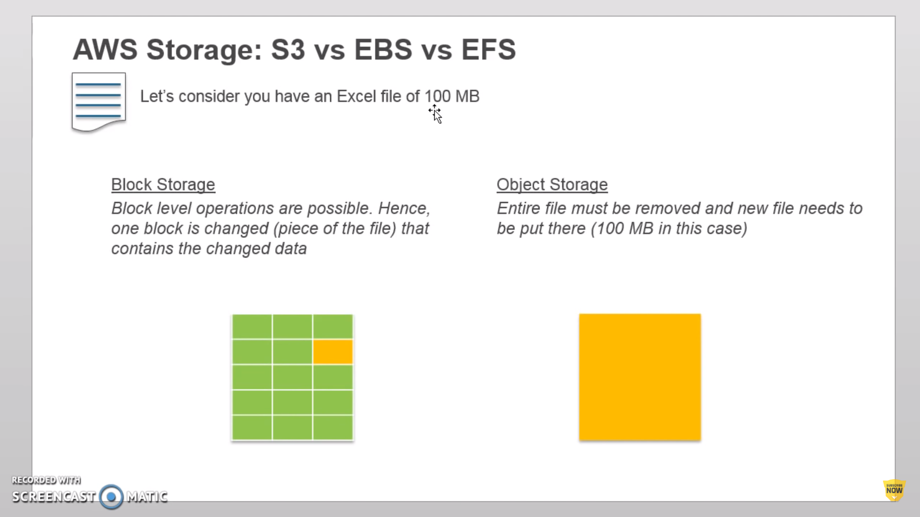

EBS can only be attached to 1 EC2 at a time and

Both EC2 and EBS must be in the same AZ.

EFS is a block level storage that can be mounted to n number of ec2-instances within the same region. EFS replicates itself across multiple AZ within a region.

EFS can be mounted to on-prem with Direct Connect.

No need of preplanning for size like EBS